Name:
M & M Science

It’s graduation day!! You are going to throw a party and want to include ONLY BLUE M&M’s to show your RAIDER PRIDE but you can only find FUNSIZE bags! How many FUNSIZE bags do you need to get 600 BLUE M&M’s for the party?

1) What do you need to know to answer?

2) Background information:
-

-

- Count the total number of M&M’s WITHOUT opening it ___________________
3) MAKE A PREDICTION:
If I open the bag, there will be __________ Blue M&M’s.

4) Count and record your numbers:
COLOR: | BLUE | RED | GREEN | BROWN | YELLOW | ORANGE
COUNT:

5) Make a bar graph to show the number of each color

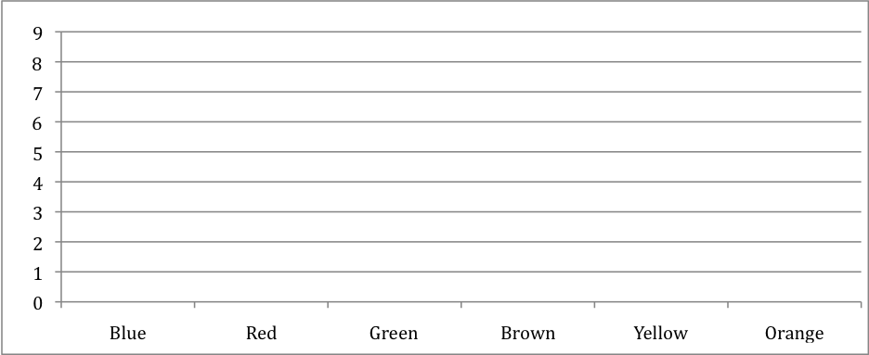

6) Was your prediction correct?
How many bags do you need to buy to get 600 Blue M&M’s? 600 ÷ _________ =

